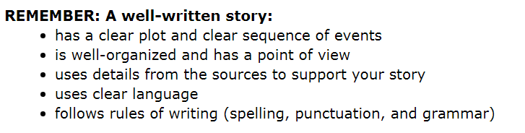Name ________________________________________ Date ______________

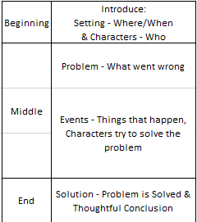

**Story Words - Transitions**

**These are examples of transition words you can use in a story to show when things happened or the passage of time.**

**Beginning:**

once upon a time, last night, one day, there once was, one night, last summer, in the beginning, it was a dark and stormy night...., (or use a question)

**Middle:**

then, all of a sudden, suddenly, later, next, so, but, still, yet, for, hence, therefore, that evening, the next morning, when spring arrived,

**Ending:**

finally, lastly, the end, in the end, at last

Instead of “said”, you can use some of these more interesting words to show someone is talking. They are called “Dialogue Tags”:

