**Opinion Writing**

**Writing what you think (your Point of View) about a topic or issue and supporting it with reasons and evidence.**

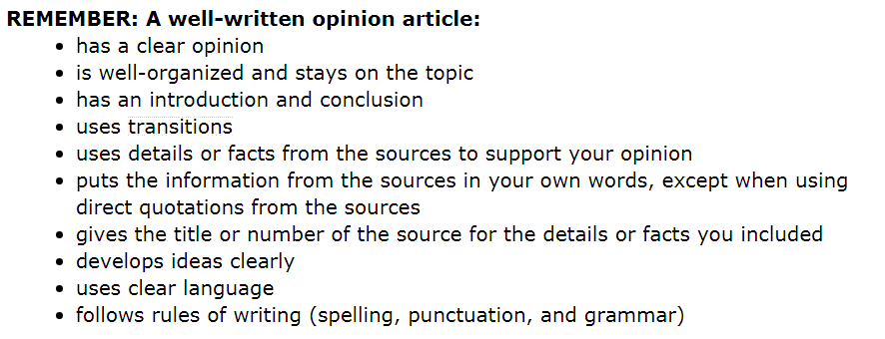Name __________________________________________________________ Date _____________________

